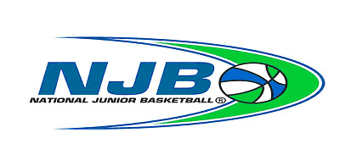 NATIONAL JUNIOR BASKETBALL
721 E. Ball Road, Suite 101, Anaheim, CA 92805
League Levels
Boys - Lev 1: A5B, A6B, A7B, A8B
Boys - Lev 2: B5B, B6B, B7B, B8B
Girls - Lev 1: A5G, A6G, A7G, A8G

85 Saratoga Ave, Suite 111, Santa Clara, CA 95051

ALL-NET TEAM ROSTER

 | Boys League |  | Girls League | Chapter: | League Level:
Team Colors |  |  |  | Section: |  | Date:
Head Coach: |  |  |  | Address: | City: | Zip:
Home Phone: |  |  |  | Cell Phone: | Fax: | E-mail:
Asst. Coach: |  |  |  | Address: | City: | Zip:
Home Phone: |  |  |  | Cell Phone: | Fax: | E-mail:
Team Parent: |  |  |  | Address: | City: | Zip:
Home Phone: |  |  |  | Cell Phone: | Fax: | E-mail:

PLAYERS – PLEASE PRINT or Type |← Official Use Only → |
Uniform # |  | NAME | ADDRESS | CITY | ZIP | PHONE | GRADE | BC | RC | Utility | Waiver
 | 1.
 | 2.
 | 3.
 | 4.
 | 5.
 | 6.
 | 7.
 | 8.
 | 9.
 | 10.
 | 11.
 | 12.

VERIFICATION: Date: ___________________ Chapter Director: _____________________________ National Headquarters: __________________________

www.siliconvalleynjb.com www.njbl.org

