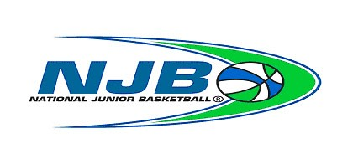
Silicon Valley NATIONAL JUNIOR BASKETBALL
85 Saratoga Avenue, Suite 111, Santa Clara, CA 95051
CHAPTER ALL-STAR TEAM WORKSHEET
Girls Division Boys Division | Chapter: | Division: | Team #: of
Team Colors: | Section: Silicon Valley NJB |  | Date:
Head Coach: | Address: | City: | Zip:
Home Phone: | Cellular Phone: | Fax: | E-mail:
Asst. Coach: | Address: | City: | Zip:
Home Phone: | Cellular Phone: | Fax: | E-mail:
Team Parent: | Address: | City: | Zip:
Home Phone: | Cellular Phone: | Fax: | E-mail:

(List players by Jersey #, if not available list players alphabetically by last name) NJB Certifier Use Only:
- Check-off validated items
- Leave missing items blank
- Mark N/A if Waiver not required
 | Uniform# | NAME (Last, First) STREET ADDRESS CITY ZIP HOME PHONE | GRADE | B.C. | R.C. | Utility | Waiver | Pic
1.
2.
3.
4.
5.
6.
7.
8.
9.
10.

Chapter Director: Date: _____________ Sectional Director: ________________________________ Date: _________
www.njbl.org
www.siliconvalleynjb.com

